**Physics 20 - Lesson 28**

**Simple Harmonic Motion – Energy & Dynamics**

/ 90

1) A simple harmonic oscillator experiences a restoring force toward the equilibrium point which depends on the distance from the equilibrium point. The further from

/2 the equilibrium point the greater the restoring force and therefore the greater the acceleration.

2)

(a) acceleration is at a maximum at the points of greatest displacement from the equilibrium position

/3

(b) the velocity is at a maximum as the oscillator passes through the equilibrium position

(c) the restoring force is at a maximum at the points of greatest displacement from the equilibrium position

3)



❑



/5

4)



/3

5)



/7



6)

/7

7)

a. from rest



/8

37o

30.0 m

x

x=30.0cos37o

x=23.959m

h=30.0 m – x

h=30.0m – 23.959m

h=6.041 m

b. starts at 4.00 m/s



8) 2 marks each for a total of 8 marks.

b. Suspended from a spring. Instantaneously at rest at the top of its travel.

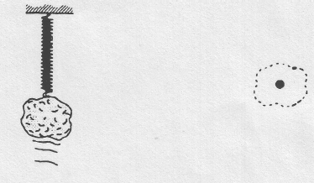

Fs

Fg

a. Suspended from a spring. Pulled downward slightly and released. No friction.

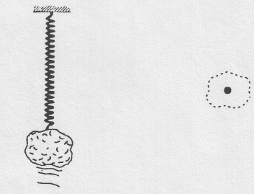

Fs

Fg

c. Suspended from a spring. Moving downward through the equilibrium position. No friction.

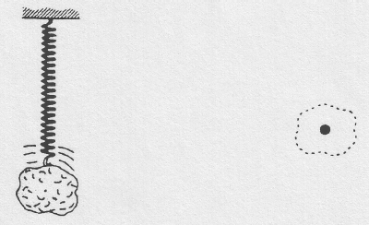

Fs

Fg

d. Suspended from a spring. Moving upward through the equilibrium position. No friction.

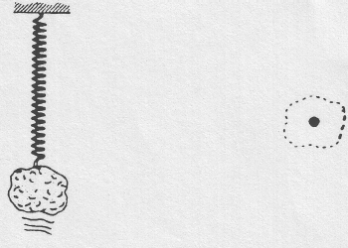

Fs

Fg

9)



/6

10)



vmax = 5.0 m/s

xmax = 0.110 m

/5

11)



/6

12)



/9



13)



/9

14)



/6

15) First, find m Second, calculate the speed when x = 0.20 m

/6

